Maleo AI Copywriting Framework
Note for hiromi170117@gmail.com : Please add Website Analytics and form to getting more data about our visitors
Primary target audiences | Startup in US, Europe, and APAC ready to scale
Pain points | Inability to compete with larger enterprises on speed / Manual processes drain resources and slow growth / Uncertainty about where AI delivers real ROI / Fear of choosing the wrong vendor and wasting budget
Business objective targeted | Lead generation for custom AI solution
Unique selling point | Custom AI automation
Tone | Consultative & trust-building (to optimize the lack of detailed portfolio)

Home Page Copy
Hero section  Tag  Custom AI Automation for Business  Headline  The Market is Moving, Are You Keeping Pace?  Subheadline  We help startup founders and scaling businesses across the US, Europe, and Asia-Pacific deploy custom AI systems that eliminate manual work, reduce operational costs, and deliver measurable competitive advantage.  CTA  - Start Your Pilot (link to contact page)  - View Case Studies (link to portfolio page) | 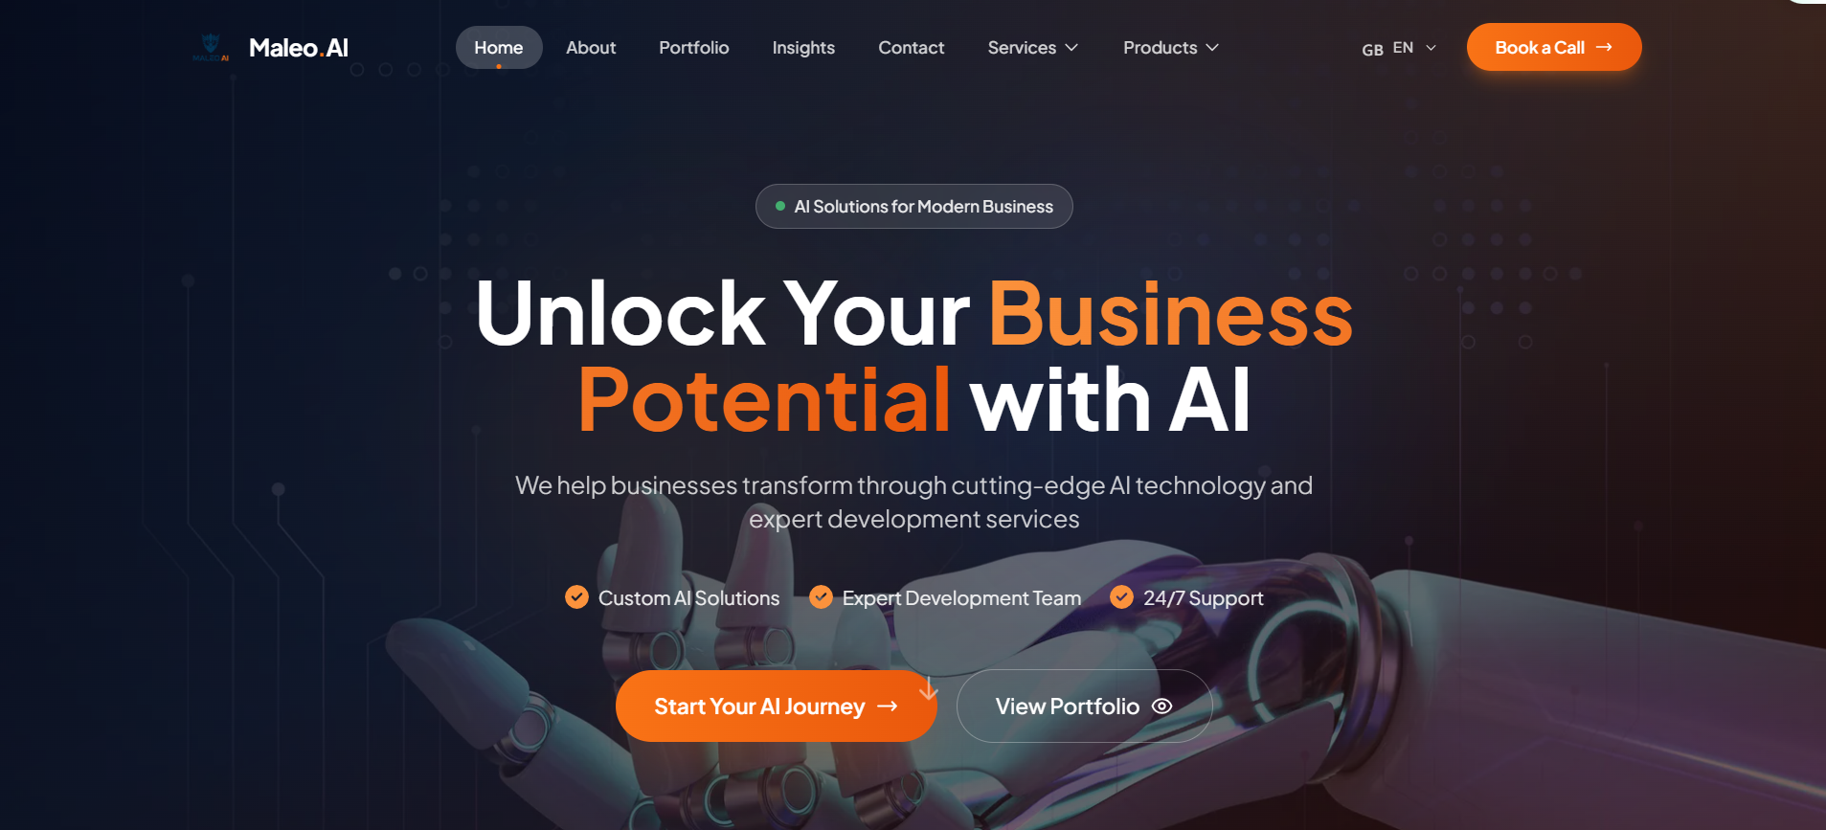
Data Support Section  Waiting has a price. | Businesses that delay AI automation lose 15–25% in annual efficiency gains to competitors who act first. For startups, that gap compounds fast. (Boston Consulting Group, 2024)  Link to here: https://www.bcg.com/publications/2025/are-you-generating-value-from-ai-the-widening-gap  Decide whether to lead or follow. | 87% of business leaders in a recent U.S. executives survey estimated AI to drive revenue growth, with nearly half anticipating gains of over 5%. (McKinsey US CxO Survey, Oct-Nov 2024)  Link to here:  https://www.mckinsey.com/capabilities/tech-and-ai/our-insights/superagency-in-the-workplace-empowering-people-to-unlock-ais-full-potential-at-work | 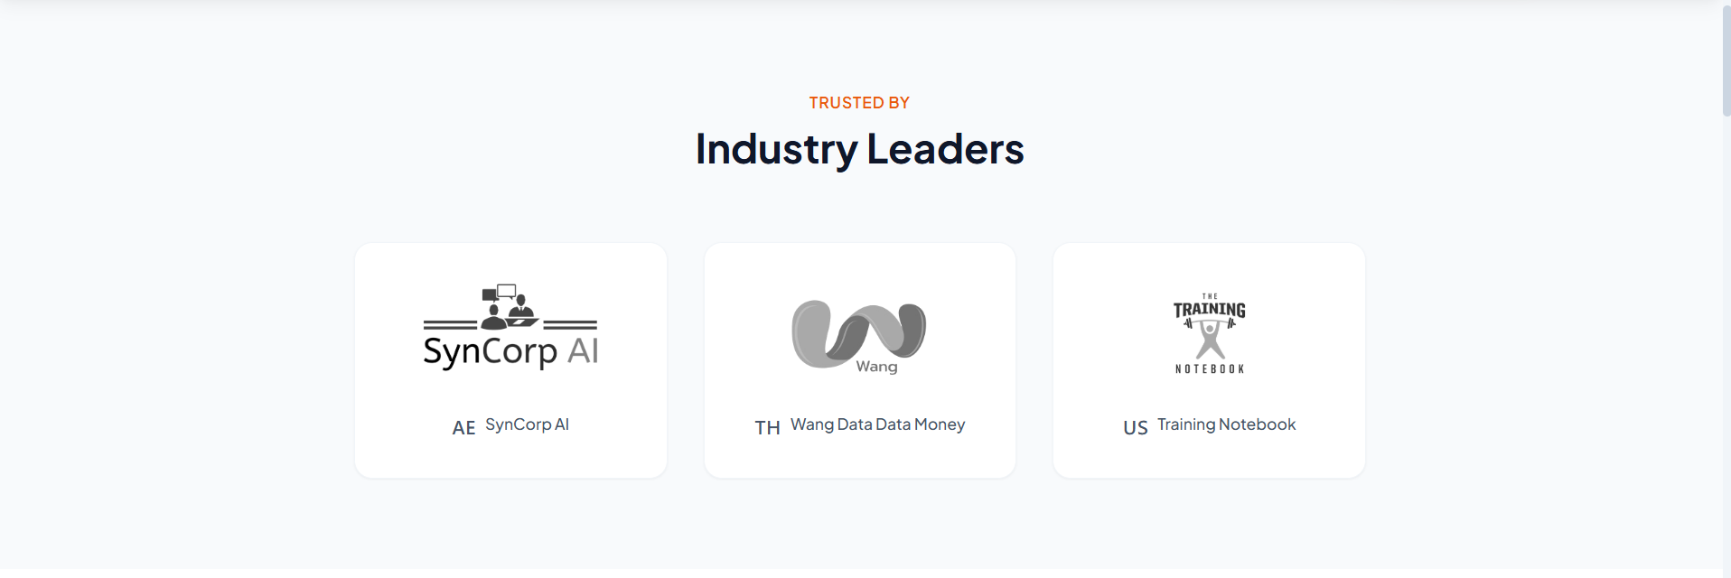
Who Are We Section

Headline: Global-Standard AI, Southeast Asia's Best Talent.

Not a traditional agency locked into fixed teams. Not a freelance platform without quality control.
We're built to fit your needs, agile and accountable.

[Core Team]
A dedicated group of AI engineers, strategists, and project leads who take full ownership of your engagement, from initial scoping through to delivery. They hold the context, drive the architecture, and remain your consistent point of accountability throughout.

[Specialist Bench]
A curated network of senior experts across AI, software development, cybersecurity, blockchain, and emerging technology engaged selectively based on what your project actually requires.

[Strategic Oversight]
We embed specialists into your workflow, oversee delivery, and maintain quality standards across every workstream. You work with one accountable team.

[Outcome to Expect]
The strategic direction and delivery accountability you would expect from a top-tier agency, with the technical depth and cost efficiency that a fixed team structure rarely allows.

No hiring risk. No team overhead. No unnecessary complexity.
[Get to Know More About Us]
Clients Section

Headline:
Maleo AI: Trusted AI Consulting for Startups

[insert client’s & partner’s logos here]
Our Services Section  Headline: What We Build  Subheadline: From automation to development, we engineer AI that transforms how you work.  [Service 1] AI Automation  We build custom workflows that reduce manual effort by 40–70% across operations, customer service, and data processing.  [Explore AI Automation]  [Service 2] Generative Engine Optimization (GEO)  With AI tools like ChatGPT, Perplexity, and Gemini now answering buyer questions directly, your business needs to show up there too.  We help you build the content architecture and AI-native presence that erase the confusion to rank in AI search.  [Explore GEO Services]  [Service 3] Custom Web & App Development  Build customer-facing products or internal tools that integrate seamlessly with your AI automation layer, and multiply the ROI of your AI investment.  [Explore Web & App Dev]  [Service 4] AI Training for Your Team  We run hands-on AI training programs that equip your people with practical skills to evaluate, deploy, and optimize AI systems. Build internal capabilities and reduce dependency on external partners.  [Explore AI Training]  [Service 5] On-Demand Technical Expertise  When a critical initiative can't wait for a lengthy hiring process, we step in. We connect you with senior technical specialists, vetted, context-ready, and deployable on your timeline. No full-time hire overhead.  Best suited for:  - MVP Development  - AI Implementation  - Security Audits  - Product Scaling  - Specialized Technical Projects  [Explore On-Demand Talent] | 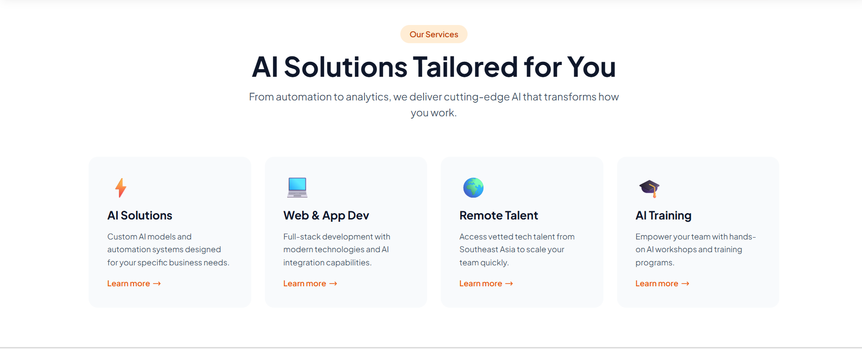
Why Choose Us Section  Headline: Built for Startups. Proven by Results.  1) Founder-First Process  We bring specific solutions to the table. Our AI consulting process for startups starts by mapping exactly where manual work is actually costing you time and money, then recommending only what's worth building.  2) Pilot-First  Before we scale, we prove it works. We implement a working proof of concept on your highest-ROI use case, you evaluate the results and make the call.  3) We Stay Accountable  We refine, measure, and re-optimize your AI system after deployment. Your investment continues to multiply, resulting in success that we continue to build on. | 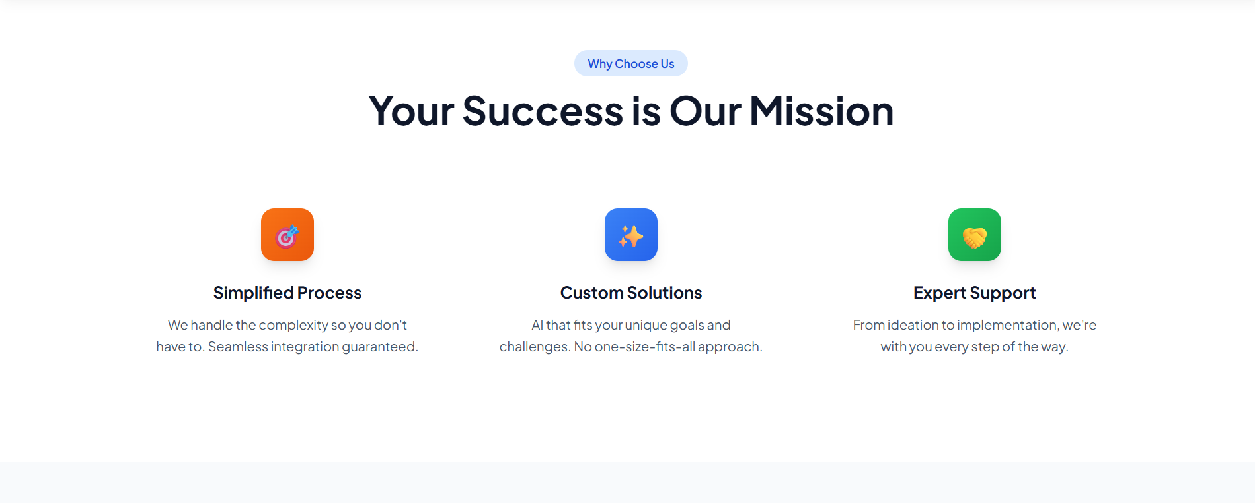
Testimonial Section  Headline: Founders Across the Globe Work With Maleo AI  [Insert Thumbnail Picture]  "As a founder, recruiting is one of the highest-stakes things you do, and getting it wrong is expensive in every sense. Febrian and the team understood that immediately. They helped us hire a UX/UI designer for MapTrack who's continued to help elevate our entire product, and the process from brief to offer felt genuinely founder-friendly — fast, well-curated, and honest about trade-offs. If you're a startup scaling fast and can't afford a mis-hire, talk to them."  Lachlan McRitchie  Founder & GM of Operations, Maptrack — Australia  [Insert Thumbnail Picture]  "Maleo AI operates as a true extension of our team, combining strong technical execution with real ownership and a deep understanding of our business goals. They have been very hard-working and humble, and helped us push our product to a mainnet launch in the early days of our company. Working with Febrian has also been a great experience — very proactive, with great communication and reliability."  David Stancel  Co-Founder & COO, Cork Protocol (DeFi derivatives platform backed by A16Z) — United States  Ready to join them? [Start Your Pilot] | Put a photo of the clients in this section. Reference below  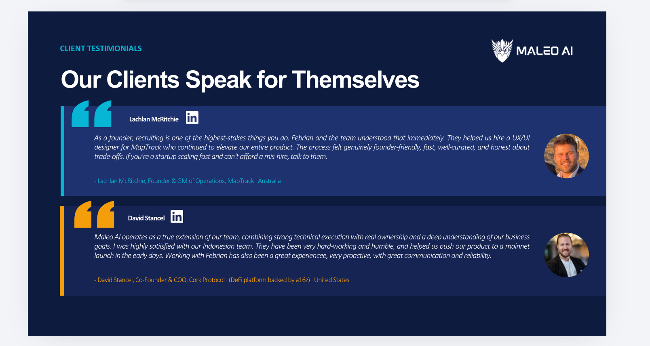
Article Recommendation Section  Headline: Stay Sharp on Newest Insights  Subheadline: AI knowledge for startups and companies who want to move fast and build right.  Article 1: BytePlus Startup Connect Bali: Strategy for Turning AI into a Sustainable Income Source  [Read More]  Article 2: AI Implementation in Companies: A Strategic Approach for Indonesian Businesses  [Read More]  [Explore All Insights →] | 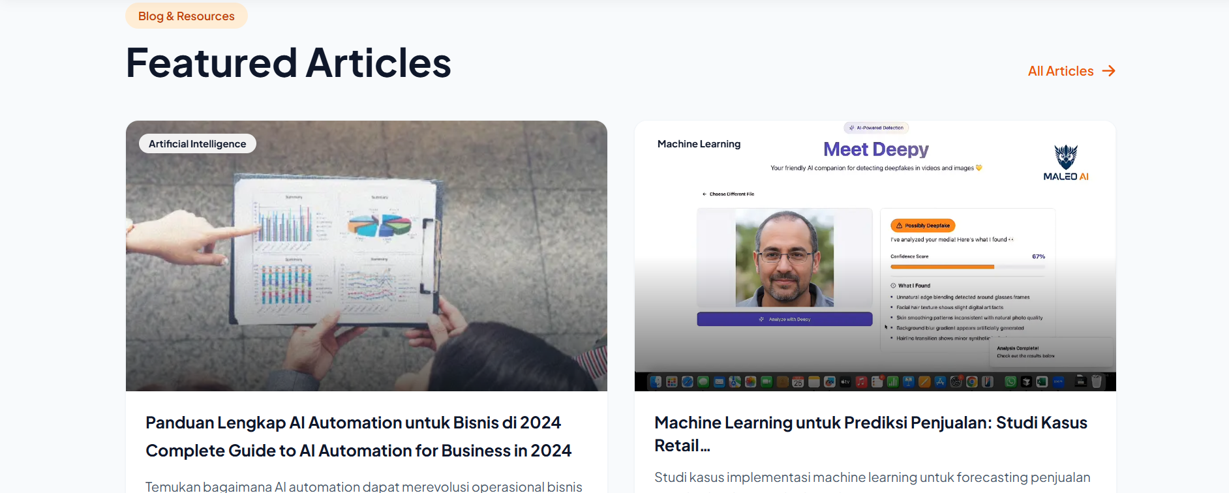
Final CTA  Headline: Don't Let Operational Friction Be Your Hurdle  Subheadline: Eliminate repetitive rework and costly errors. Whether you're exploring custom AI solutions for your business or ready to launch your first AI workflow, let AI automation clear the gap, and start to scale smarter.  CTA:  Start Your Pilot (link to form in contact page)  Schedule a Discovery Call (link to WhatsApp) | 
Frequently Asked Questions

Q: What exactly does an AI automation agency for startups do?
A: Maleo AI helps startups and companies implement AI to improve efficiency, automate workflows, and support smarter business decisions.

Beyond building software, we identify repetitive processes, operational bottlenecks, and growth opportunities where AI can create real business impact.

This can include:
- AI-powered internal tools
- Workflow automation
- Customer support AI agents
- Business intelligence & reporting systems
- Custom AI product development
- Process optimization using automation

Think of us as a mix of AI strategist, product partner, and execution team.

Q: How is Maleo AI different from a typical software development agency?
A: We combine strategic thinking, execution, and access to specialized expertise. Maleo AI is backed by a curated network of 100+ senior technology experts across APAC and Europe, allowing us to activate the right specialists in AI, software engineering, cybersecurity, blockchain and emerging technologies based on each project’s needs.

With us, clients can move faster, access niche expertise on demand, and avoid unnecessary hiring overhead for highly specialized technical work.

Q: Do you work with early-stage startups or only established companies?
A: Yes. We work with early-stage startups, founders, and growing businesses, especially teams that need technical direction but don’t want to waste time or budget building the wrong thing.

Whether you’re validating an idea, streamlining operations, or preparing to scale, we help turn ideas into practical systems. We’re especially useful for founders who need strategic thinking and execution support without building a large internal tech team too early.

Q: What industries do you serve?
A: We work across industries where AI and automation can drive meaningful efficiency and smarter decision-making.

This includes:
- Professional services
- Recruitment & HR
- Education
- Hospitality & tourism
- E-commerce
- Real estate
- Financial services
- Operations-heavy businesses

That said, we care more about the problem quality than the industry itself. If there’s inefficiency, manual work, or decision bottlenecks we’ll explore whether AI can help.

Q: How do we get started?
A: We start with a discovery call to understand your business, goals, bottlenecks, and where AI can realistically create value.

From there, we typically go through:
1) Discovery & Assessment
Understand workflows, pain points, and opportunities.

2) Strategy & Solution Design
Recommend the right AI systems, automation, or product roadmap.

3) Build & Implementation
Develop and deploy the solution.

4) Optimization & Support
Improve performance and ensure adoption.

No unnecessary complexity. Just practical AI implementation designed to make business operations smarter and more efficient.

Home Page Copy ID Version

Primary target audiences | Pain point utama: budget terbatas, skeptisisme terhadap vendor AI, takut "ditipu" atau buang-buang uang. Buying trigger: trust + jaminan hasil.
Pain points | Owner/direktur yang belum tentu paham AI secara teknis, butuh edukasi + guidance. Mereka cari partner yang bisa jelaskan dari nol.
Business objective targeted | Lead generation for custom AI solution
Unique selling point | Custom AI automation
Tone | Friendly, approachable, educating tapi tetap kredibel.

Hero section  Tag  Custom AI Automation for Business  Headline  Optimalkan Operasional Bisnis dengan AI Automation yang Bekerja Lebih Cerdas  Subheadline  Maleo AI membantu startup founder dan bisnis yang sedang berkembang di Amerika Serikat, Eropa, dan Asia-Pasifik membangun sistem AI kustom yang mampu mengurangi pekerjaan manual, menekan biaya operasional, dan menciptakan keunggulan di industri.  CTA  - Mulai Pilot Project (link to contact page)  - Lihat Studi Kasus (link to portfolio page) | 
Data Support Section  Menunda Automasi Punya Konsekuensi | Bisnis yang terlambat mengadopsi AI automation berisiko kehilangan efisiensi tahunan sebesar 15–25% dibanding kompetitor yang bergerak lebih dulu. Untuk startup, gap ini bisa berkembang jauh lebih cepat. (Boston Consulting Group, 2024)  Link to here: https://www.bcg.com/publications/2025/are-you-generating-value-from-ai-the-widening-gap  AI Automation Solusi Bisnis yang Bergerak Cepat | Sebanyak 87% pemimpin bisnis dalam survei eksekutif AS percaya AI akan mendorong pertumbuhan revenue, dan hampir separuhnya memperkirakan kenaikan lebih dari 5%. (McKinsey US CxO Survey, Oct-Nov 2024)  Link to here:  https://www.mckinsey.com/capabilities/tech-and-ai/our-insights/superagency-in-the-workplace-empowering-people-to-unlock-ais-full-potential-at-work | 
Who Are We Section

Headline: Talenta Terbaik Asia Tenggara dengan Standar Kelas Dunia

Kami bukan agency konvensional dengan struktur yang kaku, maupun platform freelance tanpa kontrol kualitas.

Kami membangun struktur kerja yang fleksibel, strategis, dan tetap accountable sesuai kebutuhan bisnis Anda.

[Core Team]
Tim inti berisi AI engineer, strategist, dan project lead yang bertanggung jawab penuh dari tahap discovery hingga delivery. Kami memahami konteks bisnis, mengarahkan arsitektur solusi, dan menjadi partner utama selama proyek berjalan.

[Specialist Bench]
Bersama para ahli senior di bidang AI, software development, cybersecurity, blockchain, dan teknologi emerging lainnya yang dilibatkan sesuai kebutuhan spesifik proyek Anda.

[Strategic Oversight]
Kami melibatkan para ahli langsung ke workflow Anda, memastikan kualitas pekerjaan konsisten di setiap tahap. Anda tetap bekerja dengan satu tim yang jelas dan bertanggungjawab.

[Outcome to Expect]
Pendekatan strategis dan kualitas delivery setara top-tier agency, dipadukan dengan fleksibilitas teknis dan efisiensi biaya yang sulit dicapai oleh struktur tim konvensional.

Tanpa risiko rekrutmen yang salah, atau struktur tim yang membebani.
[Kenali Maleo AI Lebih Lanjut]
Clients Section

Headline:
Maleo AI: Partner AI Consulting yang Dipercaya Startup

[insert client’s & partner’s logos here]
Our Services Section  Headline: Layanan Kami  Subheadline: Dari automasi hingga product development, kami membangun sistem AI yang mengubah cara bisnis Anda bekerja.  [Service 1] AI Automation  Kami membangun workflow AI kustom yang mampu mengurangi pekerjaan manual hingga 40–70% di area operasional, customer service, dan pengolahan data.  [Jelajahi AI Automation]  [Service 2] Generative Engine Optimization (GEO)  Platform AI seperti ChatGPT, Perplexity, dan Gemini kini mulai menjadi tempat orang mencari jawaban sebelum membeli produk atau layanan.  Kami membantu bisnis Anda membangun struktur konten dan AI-native presence agar lebih mudah ditemukan dan direkomendasikan oleh AI search engine.  [Jelajahi GEO Services]  [Service 3] Custom Web & App Development  Bangun produk digital atau internal tools yang terintegrasi langsung dengan sistem AI bisnis Anda untuk memaksimalkan efisiensi dan ROI investasi teknologi.  [Jelajahi Web & App Dev]  [Service 4] AI Training for Your Team  Program pelatihan AI praktikal untuk membantu tim Anda memahami, mengimplementasikan, dan mengoptimalkan penggunaan AI dalam operasional sehari-hari.  Bangun kapabilitas internal dan kurangi ketergantungan pada vendor eksternal.  [Jelajahi AI Training]  [Service 5] On-Demand Technical Expertise  Ketika bisnis membutuhkan eksekusi cepat tanpa proses hiring yang panjang, kami hadir membantu.  Kami menghubungkan Anda dengan technical specialist senior yang sudah tervalidasi, siap bekerja, dan dapat langsung menyesuaikan dengan konteks proyek Anda tanpa beban hiring full-time.  Direkomendasikan untuk:  - MVP Development  - AI Implementation  - Security Audits  - Product Scaling  - Specialized Technical Projects  [Jelajahi On-Demand Talent] | 
Why Choose Us Section  Headline: Bekerja secara Adaptif, Dipercaya Berdasarkan Hasil  1) Founder-First Process  Kami tidak menjual solusi generik.  Proses consulting kami dimulai dengan memetakan bottleneck operasional dan area manual work yang benar-benar menghambat bisnis Anda, lalu fokus membangun solusi yang memang layak diimplementasikan.  2) Pilot-First  Sebelum melakukan scaling, kami membuktikan hasilnya terlebih dahulu.  Kami membangun proof of concept pada use case dengan potensi ROI tertinggi agar Anda bisa mengevaluasi dampaknya secara nyata sebelum melangkah lebih jauh.  3) We Stay Accountable  Implementasi bukan akhir dari proses. Kami membantu melakukan refinement, monitoring, dan optimasi berkelanjutan agar sistem AI Anda terus berkembang dan memberikan dampak bisnis yang lebih besar dari waktu ke waktu. | 
Testimonial Section  Headline: Kata Founders yang Telah Bekerja dengan Maleo AI  [Insert Thumbnail Picture]  "Sebagai founder, proses hiring adalah keputusan besar yang mahal jika salah. Febrian dan tim langsung memahami itu sejak awal. Mereka membantu kami menemukan UX/UI Designer untuk MapTrack yang sampai sekarang berkontribusi besar terhadap pengembangan produk kami. Prosesnya cepat, terkurasi, transparan, dan sangat founder-friendly. Jika Anda startup yang sedang scaling dan tidak punya ruang untuk salah hire, Maleo AI layak diajak bicara."  Lachlan McRitchie  Founder & GM of Operations, Maptrack — Australia  [Insert Thumbnail Picture]  "Maleo AI bekerja layaknya extension dari tim internal kami. Mereka memiliki eksekusi teknis yang kuat, ownership yang tinggi, dan benar-benar memahami arah bisnis kami. Timnya sangat humble dan hardworking, serta membantu kami mendorong produk hingga tahap mainnet launch di fase awal perusahaan. Bekerja dengan Febrian juga sangat menyenangkan — komunikatif, proaktif, dan dapat diandalkan."  David Stancel  Co-Founder & COO, Cork Protocol (DeFi derivatives platform backed by A16Z) — United States  Ikuti Kesuksesan Mereka [Mulai Pilot Project] | Put a photo of the clients in this section. Reference below  -
Article Recommendation Section  Headline: Kabar Bisnis dan Seputar AI  Subheadline: Insight dan strategi AI untuk startup dan bisnis yang ingin bergerak lebih cepat dan membangun dengan lebih tepat.  Article 1: BytePlus Startup Connect Bali: Strategy for Turning AI into a Sustainable Income Source  [Read More]  Article 2: AI Implementation in Companies: A Strategic Approach for Indonesian Businesses  [Read More]  [Explore All Insights →] | 
Final CTA  Headline: Jangan Biarkan Beban Operasional Menghambat Pertumbuhan Bisnis Anda  Subheadline: Kurangi tugas berulang dan bangun sistem kerja yang lebih terukur. Jelajahi berbagai potensi AI automation dengan kerangka kerja yang lebih cerdas, dan percepat pertumbuhan bisnis bersama kami.  CTA:  Mulai Pilot Project (link to form in contact page)  Jadwalkan Discovery Call (link to WhatsApp) | 
Frequently Asked Questions

Q: Sebenarnya apa yang dilakukan AI automation agency untuk startup?
A: Maleo AI membantu startup dan perusahaan mengimplementasikan AI untuk meningkatkan efisiensi kerja, mengotomatisasi workflow, dan mendukung pengambilan keputusan bisnis yang lebih cerdas.

Bukan hanya membangun software, kami juga membantu mengidentifikasi proses repetitif, bottleneck operasional, dan peluang pertumbuhan di mana AI dapat memberikan dampak bisnis yang nyata.

Layanan ini dapat mencakup:

- AI-powered internal tools
- Workflow automation
- AI customer support agents
- Business intelligence & reporting systems
- Custom AI product development
- Process optimization berbasis automation

Maleo AI bekerja sebagai kombinasi AI strategist, product partner, dan execution team dalam satu ekosistem.

Q: Apa yang membedakan Maleo AI dari software development agency biasa?
A: Kami menggabungkan strategic thinking, eksekusi teknis, dan akses ke specialist berpengalaman dalam satu model kerja.

Maleo AI didukung jaringan terkurasi berisi 100+ expert senior teknologi di APAC dan Eropa, memungkinkan kami menghadirkan specialist yang tepat sesuai kebutuhan proyek mulai dari AI, software engineering, cybersecurity, blockchain, hingga emerging technologies.

Dengan pendekatan ini, klien dapat bergerak lebih cepat, mendapatkan niche expertise sesuai kebutuhan, dan menghindari overhead hiring untuk posisi teknis yang sangat spesifik.

Q: Apakah Maleo AI hanya bekerja dengan perusahaan besar?
A: Tidak. Kami juga bekerja dengan early-stage startup, founder, dan bisnis berkembang, terutama tim yang membutuhkan arahan teknis yang tepat tanpa membuang waktu dan budget membangun solusi yang salah.

Baik untuk validasi ide, meningkatkan efisiensi operasional, maupun mempersiapkan scaling bisnis, kami membantu mengubah ide menjadi sistem yang lebih praktikal dan siap dijalankan.

Pendekatan kami sangat cocok untuk founder yang membutuhkan strategic thinking dan execution support tanpa harus membangun tim tech internal besar terlalu cepat.

Q: Industri apa saja yang biasa Maleo AI tangani?
A: Kami bekerja lintas industri yang memiliki potensi peningkatan efisiensi dan pengambilan keputusan melalui AI dan automation.

Beberapa di antaranya:
- Professional services
- Recruitment & HR
- Education
- Hospitality & tourism
- E-commerce
- Real estate
- Financial services
- Operational-heavy businesses

Namun fokus utama kami bukan pada industrinya, melainkan pada kualitas problem yang ingin diselesaikan. Jika ada inefficiency, manual work, atau bottleneck dalam proses bisnis, kami akan mengeksplorasi bagaimana AI dapat membantu.

Q: Bagaimana proses memulai kerja sama dengan Maleo AI?
A: Kami memulai dengan discovery call untuk memahami bisnis Anda, tujuan yang ingin dicapai, bottleneck operasional, dan area di mana AI dapat memberikan value secara realistis.

Biasanya proses akan berjalan melalui tahap berikut:

1) Discovery & Assessment
Memahami workflow, pain point, dan peluang optimasi.

2) Strategy & Solution Design
Merancang roadmap AI, automation, atau solusi digital yang paling relevan untuk bisnis Anda.

3) Build & Implementation
Mengembangkan dan mengimplementasikan solusi.

4) Optimization & Support
Melakukan monitoring, optimasi performa, dan memastikan sistem dapat diadopsi dengan baik.

Tanpa kompleksitas yang tidak penting.
Hanya implementasi AI yang praktikal, relevan, dan benar-benar membantu bisnis bekerja lebih cerdas.

Update Page About US
Our Expertise :  Add more service :  - Generative Engine Optimization (GEO)  With AI tools like ChatGPT, Perplexity, and Gemini now answering buyer questions directly, your business needs to show up there too.  We help you build the content architecture and AI-native presence that erase the confusion to rank in AI search | 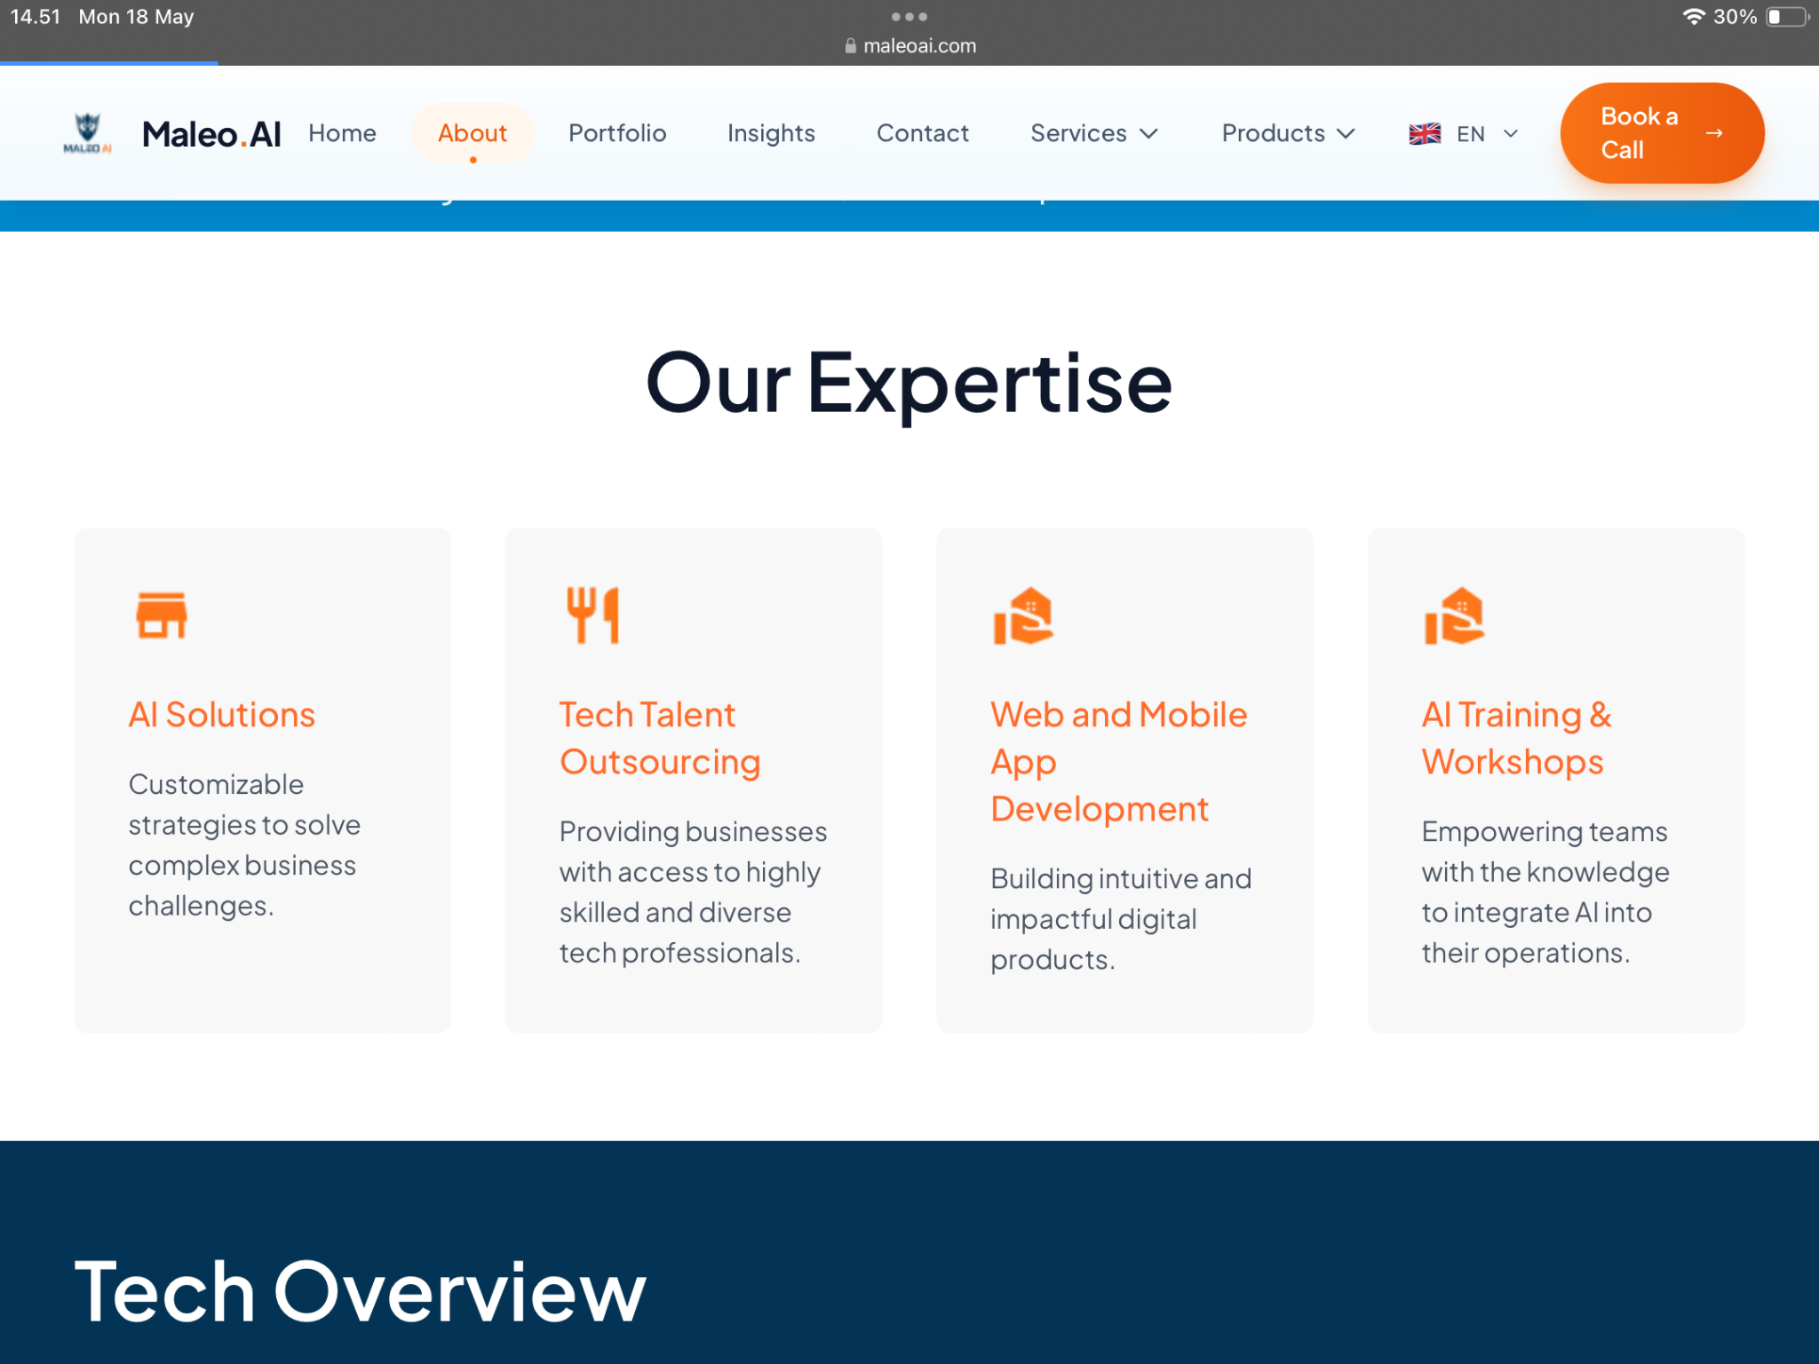
Meet Our Team  Add :  - Febrian ( Talent Ops and UX Product Researcher)  Experienced in managing recruitment processes across more than 15 countries, filling roles ranging from engineers to senior leadership positions. Strong focus on fintech, tech startups, healthcare, banking, AI, and blockchain industries. Focused on product research and human - AI interaction systems at Maleo AI. | 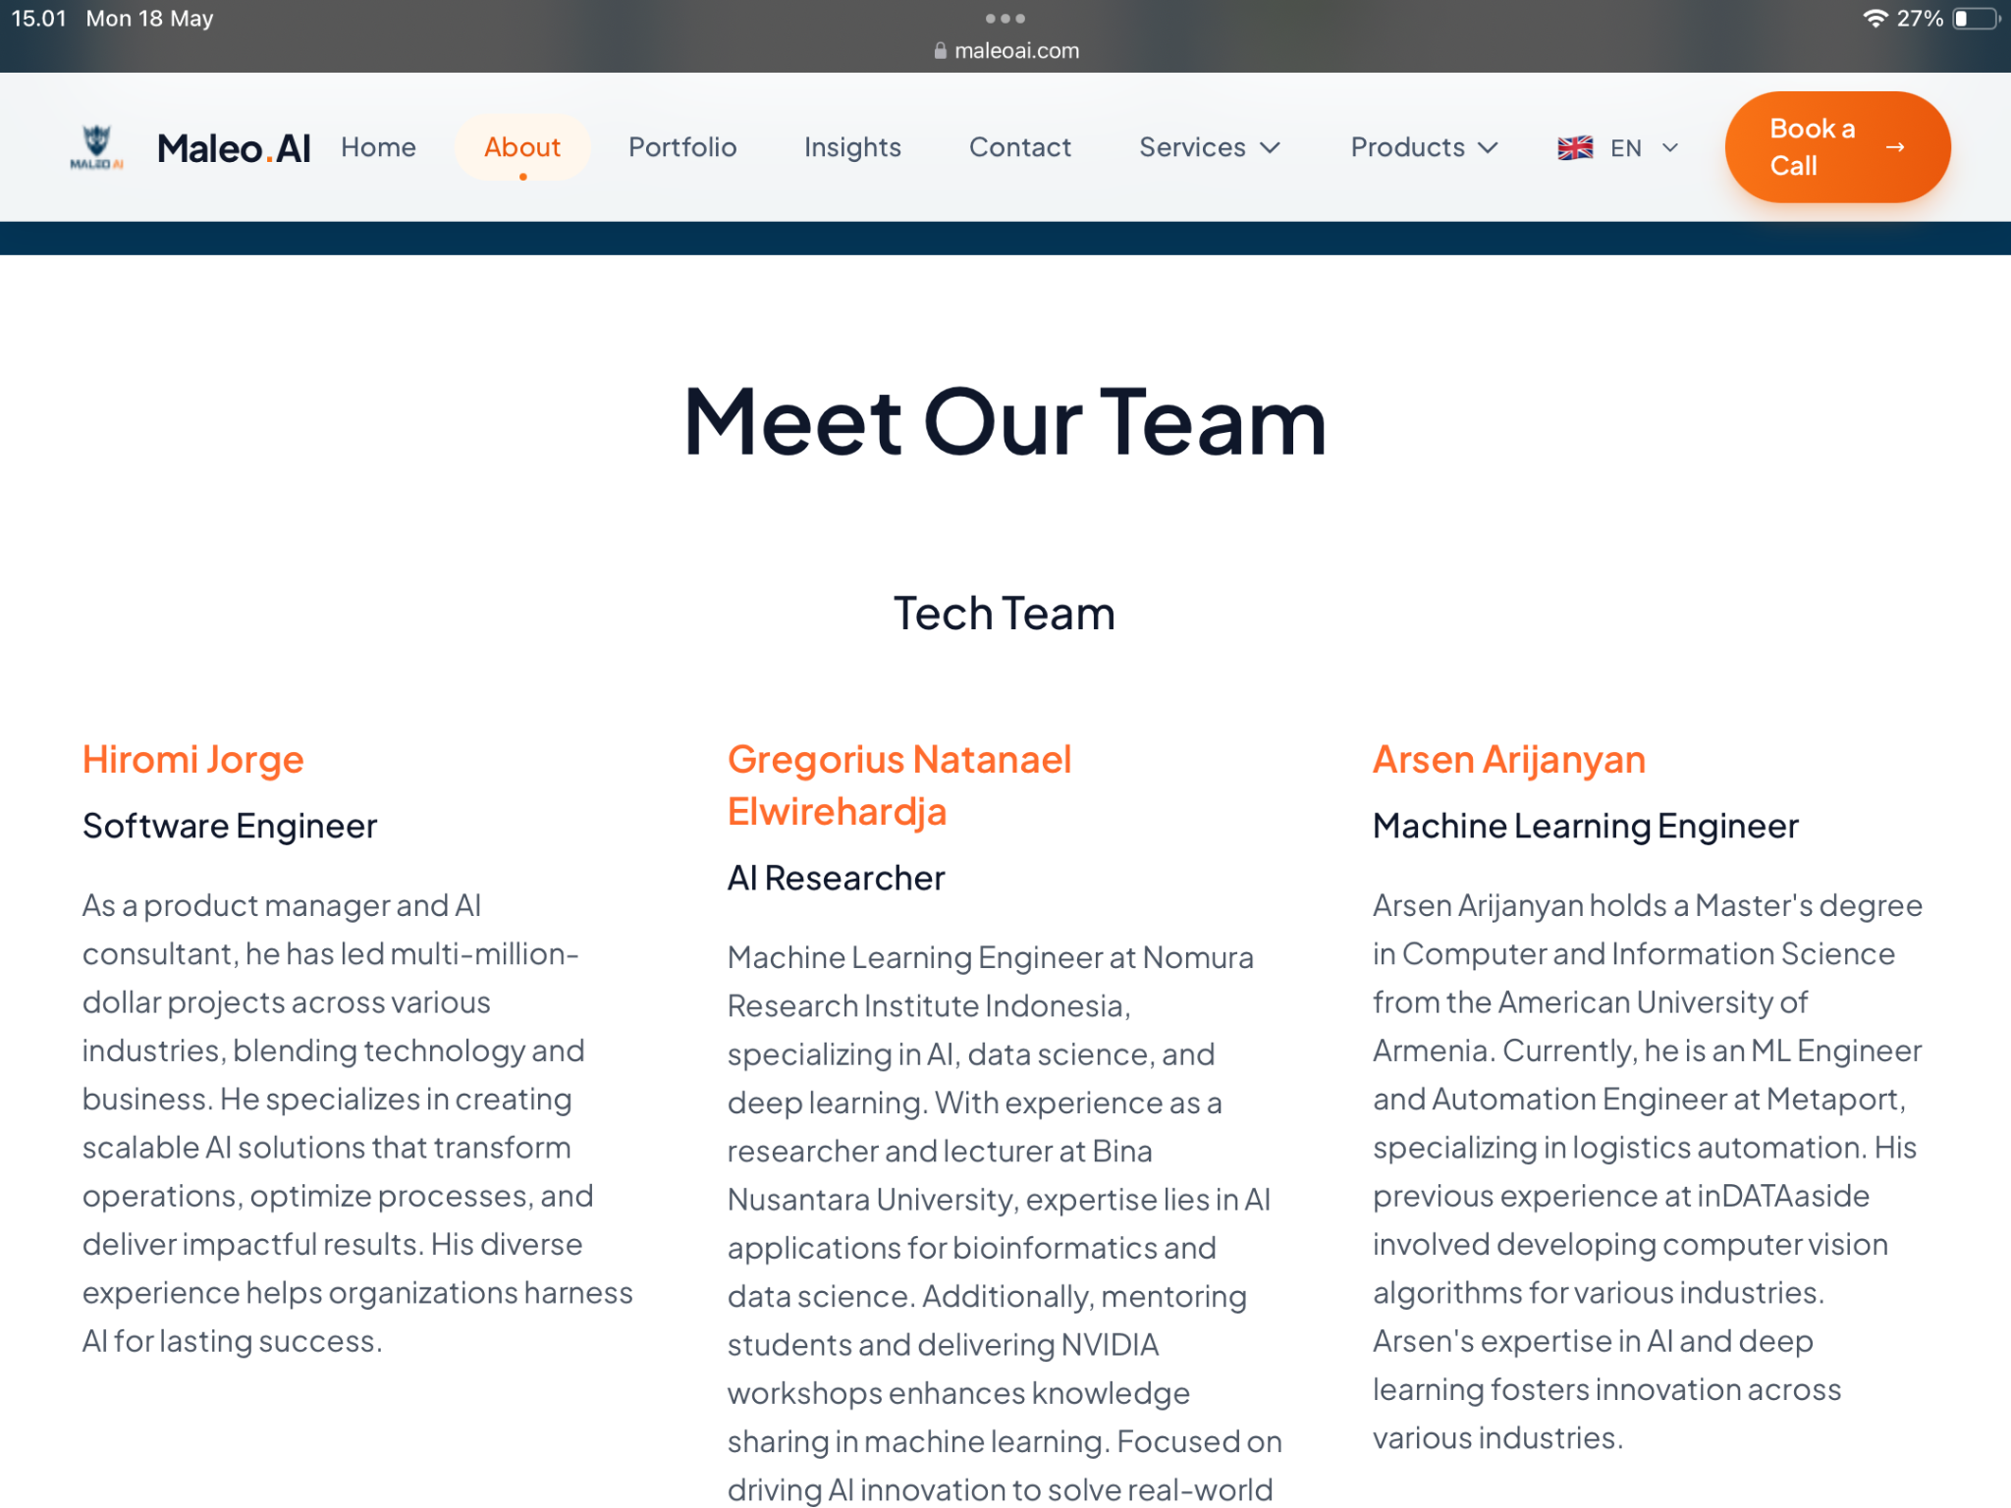
Part Services :  Add Generative Engine Optimization (GEO) | 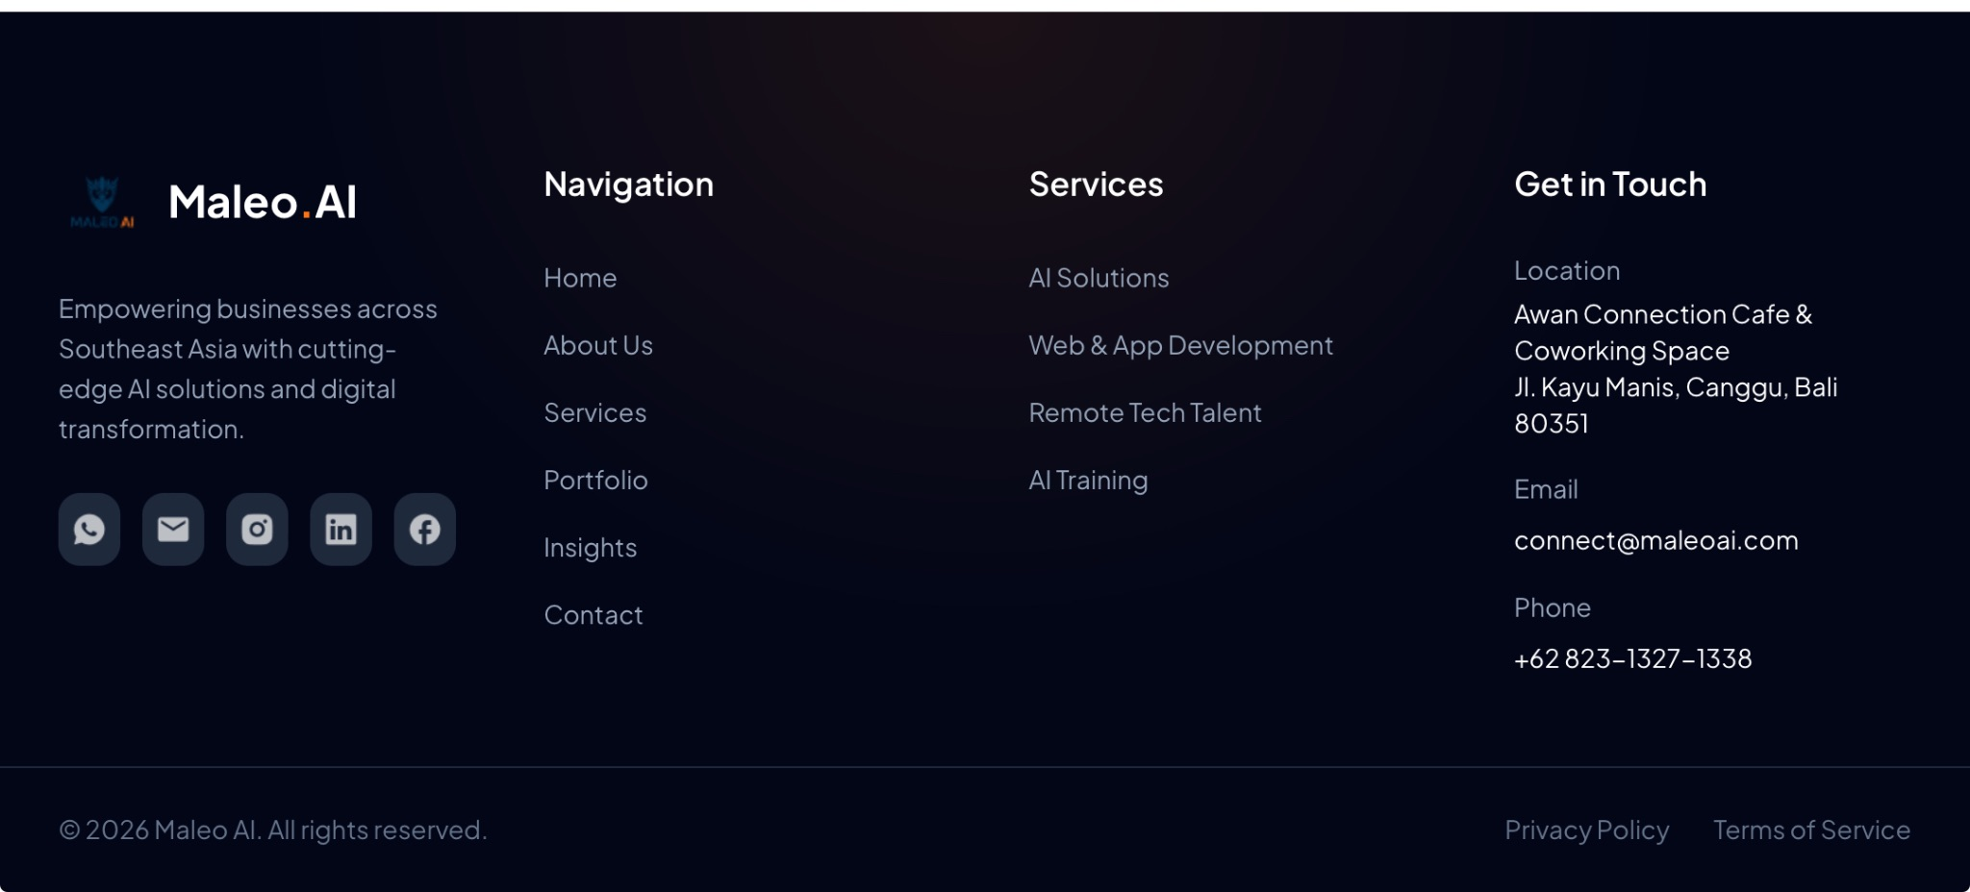

Update Page Services
Generative Engine Optimization (GEO)
With AI tools like ChatGPT, Perplexity, and Gemini now answering buyer questions directly, your business needs to show up there too.
We help you build the content architecture and AI-native presence that erase the confusion to rank in AI search
CTA : Fill the form for Free Audit Website
Note : Add Informations from docs on the group

Update page - Remote Talent  Add :  Maleo AI is backed by a curated network of 100+ senior technology experts across APAC and Europe, allowing us to activate the right specialists in AI, software engineering, cybersecurity, blockchain and emerging technologies based on each project’s needs.  With us, clients can move faster, access niche expertise on demand, and avoid unnecessary hiring overhead for highly specialized technical work. | 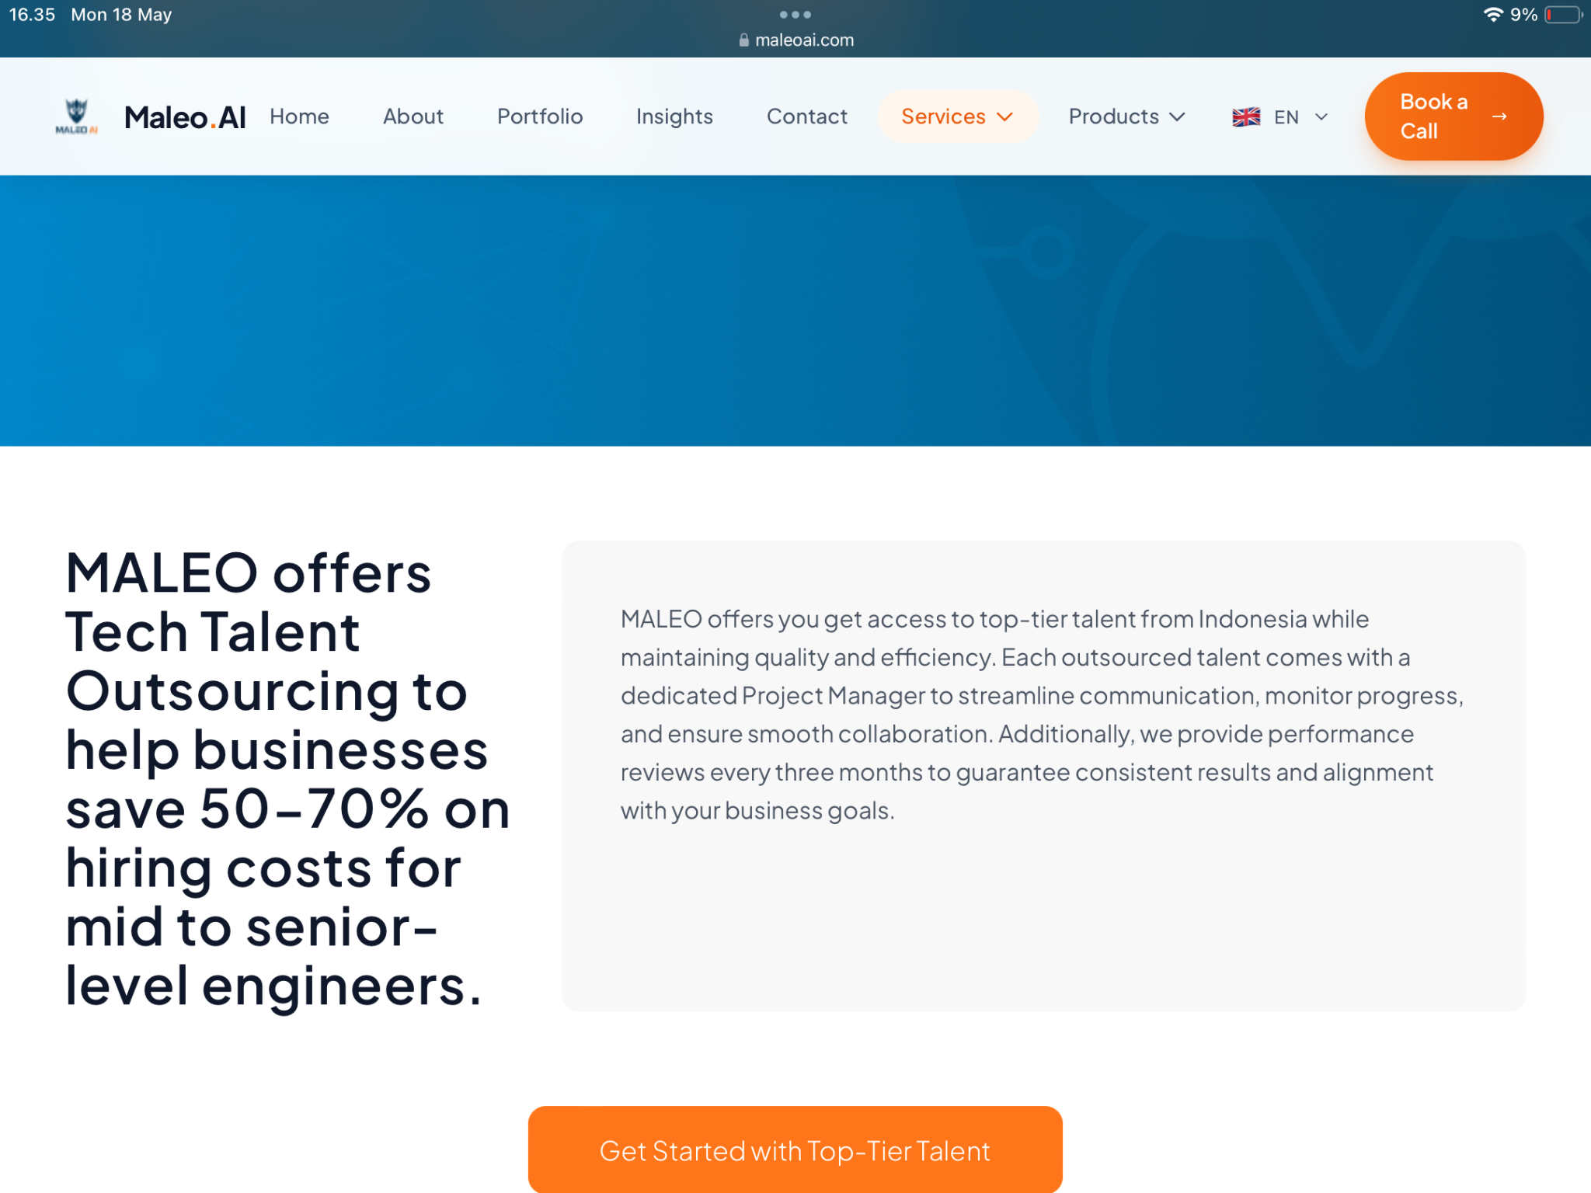
Update AI Training and Workshop | 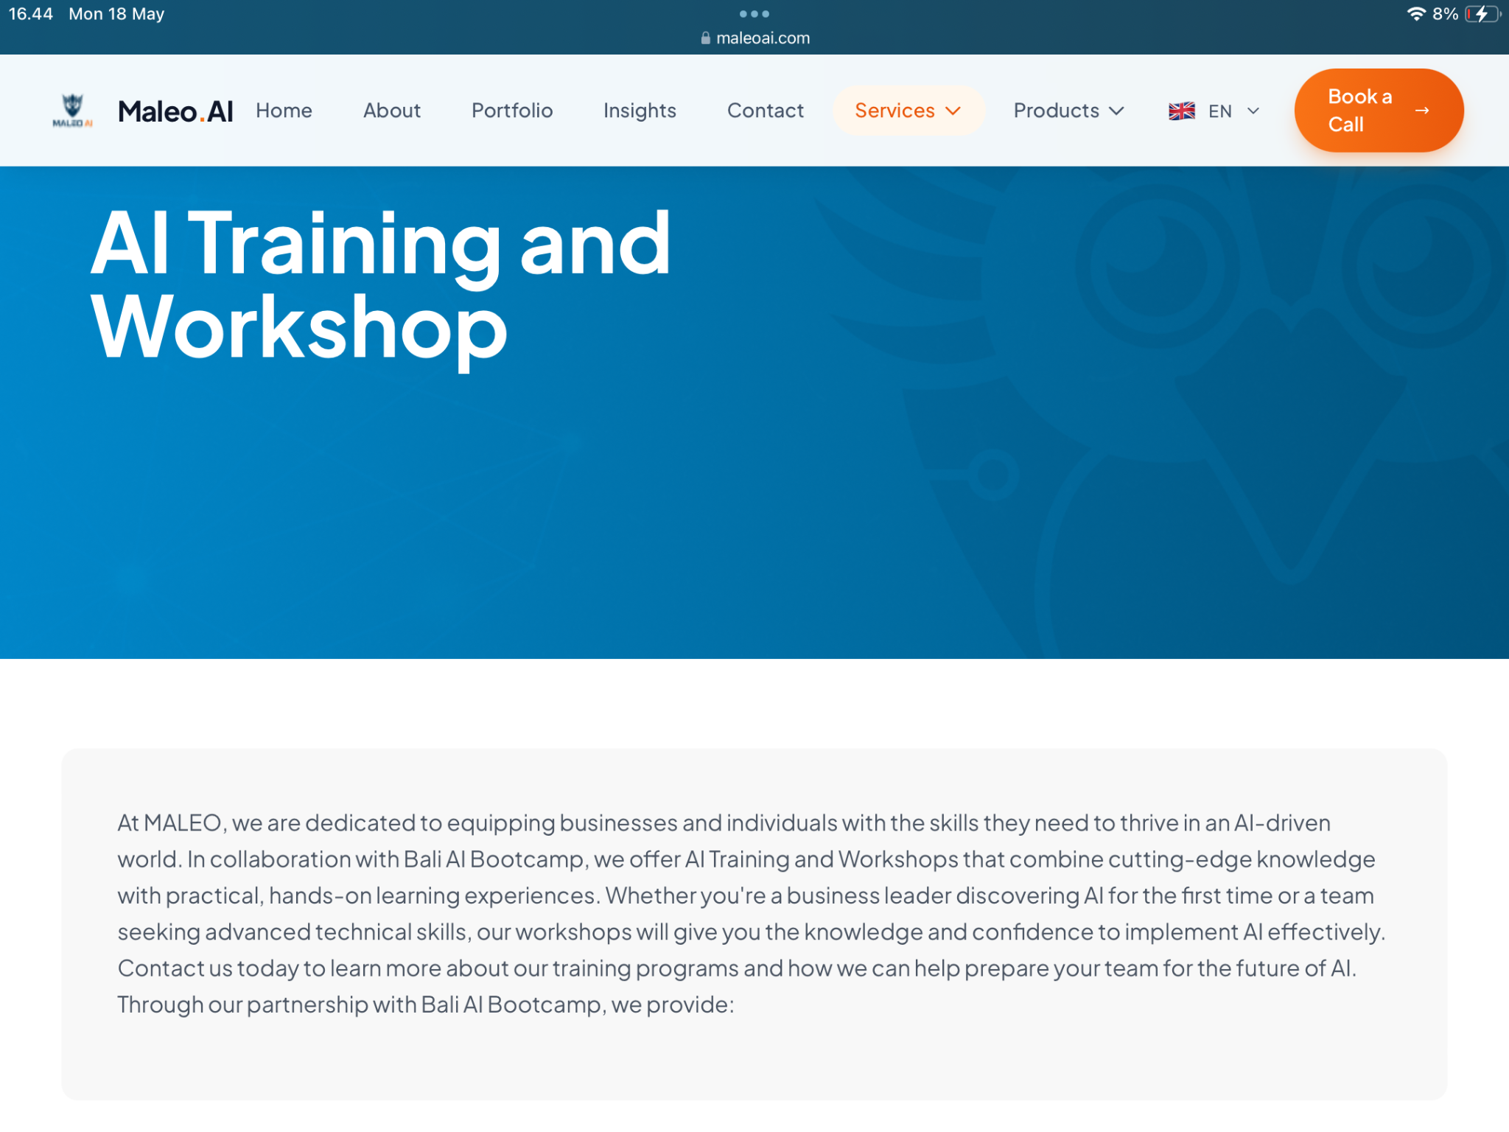
AI TRAINING & WORKSHOP ( UPDATED)
Your team doesn't need to understand algorithms. They need to know how AI solves your business problems.
We train Indonesian businesses to evaluate, deploy, and manage AI solutions independently, without relying on expensive external consultants.
53%  of CEOs know AI is important, but their teams aren't ready to act on it | 2–3 mo  typical payback period from a single automated process | 8  AI solutions implemented by Bali workshop participants within 30 days
THE PROBLEM
Why most Indonesian businesses struggle with AI
Building AI tools quickly is easy. Making sure those tools are safe, stable, and maintainable by your team, that's the hard part.
Fragmented data  Most mid-sized Indonesian businesses store data across disconnected systems. Nobody gets the full picture, and AI can't work with scattered inputs. | AI security blind spots  Threats like deepfakes and fake documents are growing, but most teams don't yet have protocols to detect or defend against them.
Single-person dependency  When the one person who understands your AI system leaves, everything can fall apart. That knowledge needs to live in the team, not the individual. | Wasted tech investment  AI tools get purchased, then go unused. Money is spent, but value is never realized, because teams weren't trained to use them confidently.
OUR SERVICES
Three ways we help your team
We don't teach complex data science. We teach your team how to evaluate, deploy, and optimize AI for real business problems.
01 Interactive workshop
Your team learns by doing, working with live AI tools on real scenarios from Indonesian industries, not sitting through algorithm lectures. No coding required.
2–3 days · Onsite & remote · Finance, ops, marketing · No coding required
02 Custom AI application + training
We build an AI solution tailored to your specific workflows, then train your internal team to manage, update, and improve it independently. You own the system fully when we're done.
2–4 months · Industry-specific · Full internal ownership
03 Continuous support & knowledge transfer
AI isn't a one-time project. We stay available after launch, document every process, and ensure new team members can learn from your internal experts.
Ongoing · Internal documentation · Train-the-trainer
WHY MALEO AI
What makes us different for Indonesian businesses
We understand your context  Training in Indonesian and English. Examples drawn from local industries. We know how Indonesian businesses actually operate. | Practical first, technical second  We start with the business outcome you want, then show how AI gets you there. Just enough theory to use tools with confidence.
Your team owns everything  When we're done, your team manages the system independently. No ongoing dependency on expensive external consultants. | Flexible to your needs  From a one-day workshop to a multi-month implementation. Onsite or remote. Always scoped to your timeline and budget.
WHAT TO EXPECT
Results over time
0–3 months | Foundation in place  - Team understands AI fundamentals and can evaluate solutions  - First AI tools deployed without external help  - Manual work in key processes starts to reduce
3–6 months | Measurable efficiency gains  - Custom AI solutions built and owned by your internal team  - Faster processes, fewer errors across departments  - Reliance on external consultants decreases
6+ months | AI as infrastructure  - AI is embedded in how your business operates day-to-day  - Your team adapts solutions as the business evolves  - A foundation for continued digital transformation
REAL IMPLEMENTATIONS
Case studies
1. AI for sales acceleration
Lead Discovery App: automating the sales pipeline
The challenge
Sales teams were spending most of their time on research, hunting for prospects, validating leads, and updating records before any actual selling could happen.
What we did
We built a Lead Discovery App that automates prospect identification, data enrichment, segmentation, automated outreach, and CRM synchronization. Then we trained the sales team to use, monitor, and continuously improve the system themselves.
Result: Pipeline fills faster. Customer acquisition costs dropped. The team now manages and optimizes the system independently.
2. SME workshop in Bali
AI for small businesses: tourism, restaurants, retail
The challenge
Small business owners in Bali wanted to use AI but assumed it was only for large tech companies. They didn't know what tools were accessible or affordable for their context.
What we did
We ran a hands-on workshop demonstrating practical, affordable AI tools applied to their specific industries: tourism, restaurants, and retail.
Result: Participants implemented 8 AI solutions within 30 days. All running independently without ongoing external support.
3. BytePlus Startup Connect Bali
From manual AI use to AI-powered operations
The challenge
Most people treat AI as an additional skill, used manually for one-off tasks. The result is limited productivity gains, fragmented workflows, and no long-term scalability.
What we did
At BytePlus Startup Connect Bali, Maleo AI introduced a different framing: AI isn't just a tool, it's leverage. We shared how startups can identify the right use cases, implement tailored solutions, and embed them into day-to-day operations as infrastructure,not experimentation.
Result: Founders shifted from 'How do I use AI?' to 'How do I build systems powered by AI?', moving from productivity hacks to scalable execution.
FAQ
Questions people ask
Does my team need to know programming?
No. We focus on using AI tools and interpreting results, not writing code. If your team can use Excel, they can learn this.
How long does training take?
It depends on your needs. A foundational workshop runs 2–3 days. Building a custom solution with full team training typically takes 2–4 months.
What if something goes wrong after training?
We provide ongoing support. Your team will also be equipped to handle issues themselves and will know when to reach out to us.
Is this worth the cost?
One automated process typically covers the cost of training within 2–3 months. After that, the savings compound continuously.
Can you train a remote team?
Absolutely. We offer flexible onsite and remote delivery. The tools and methods work just as effectively in a remote setting.
What happens when new team members join?
We provide comprehensive documentation and train-the-trainer programs so new hires can learn from your internal experts without needing to bring us back in.

FREE CONSULTATION
Schedule a 30-minute session with us
Tell us about your business challenges. We'll help identify concrete steps your team can take.
To schedule your free consultation, please contact us via:
- Website form: maleoai.com
- Email:
- WhatsApp:
We will respond within one business day to confirm your session.

